PROGRAM
import cv2
image = cv2.imread("flower.jpg")
if image is None:
print("Image not found")
else:
cv2.imshow("Original Image", image)
edges = cv2.Canny(image, 100, 200)

cv2.imshow("Canny Edge Image", edges)

cv2.waitKey(0)
cv2.destroyAllWindows()
COMMANDS USED
cd Desktop
cd opencv
python image_canny.py
INPUT
The input image used in this experiment is:
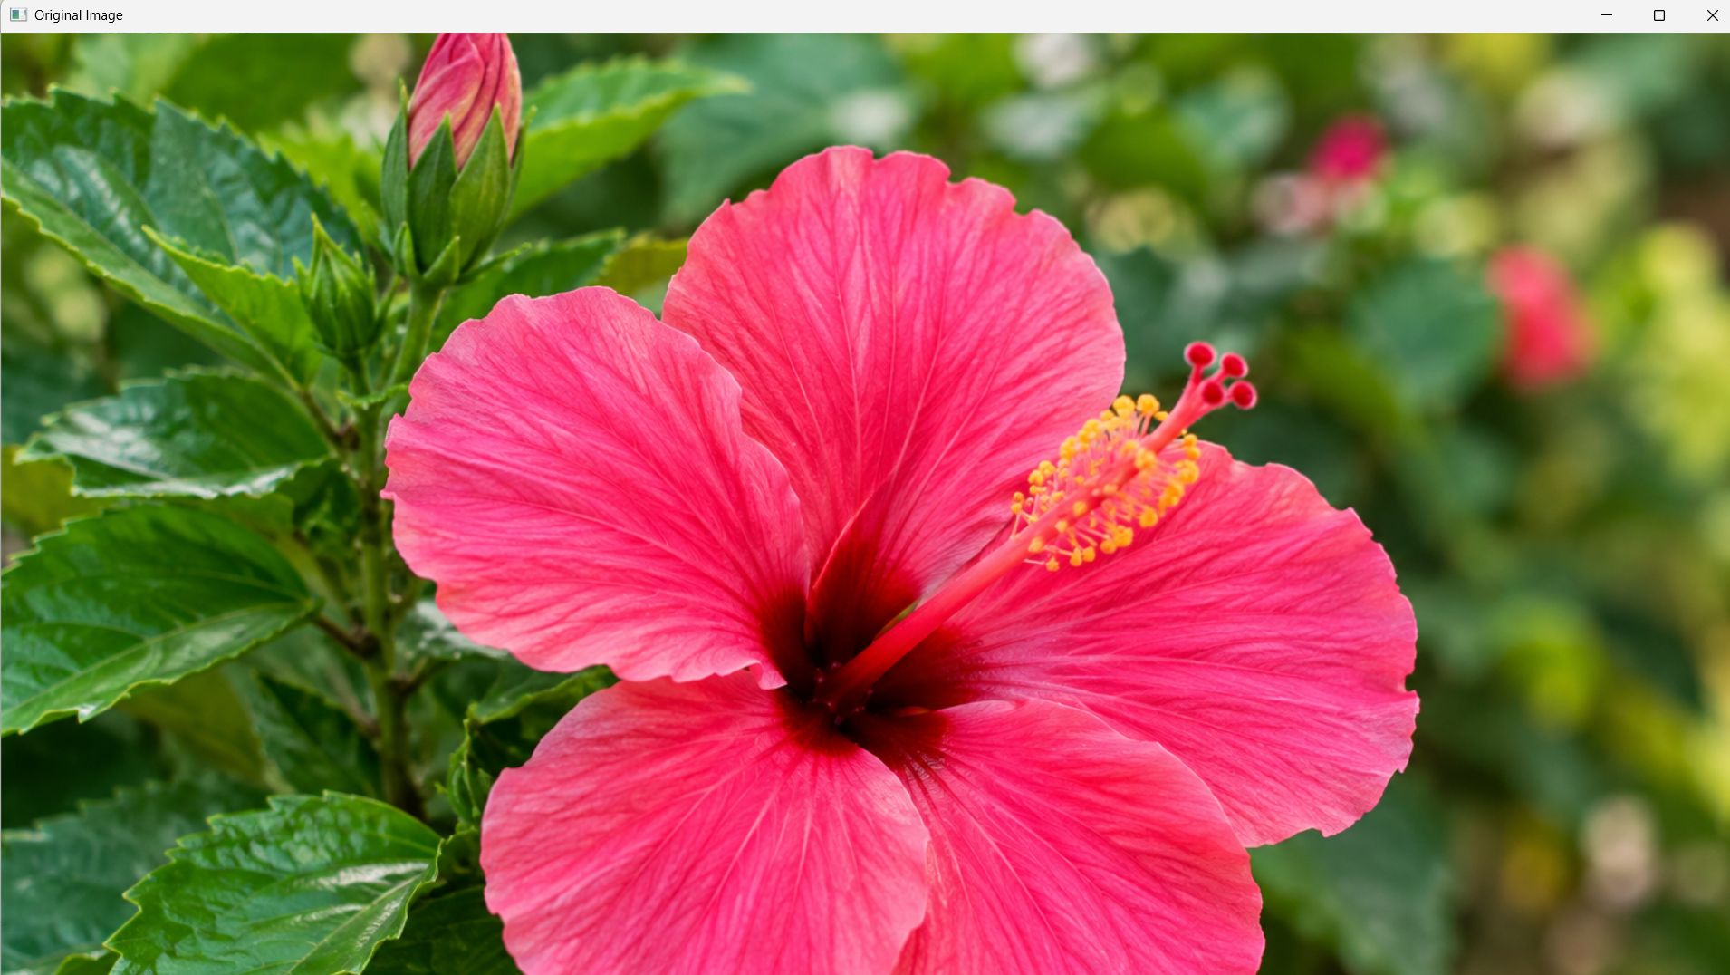
flower.jpg

OUTPUT
The program displays two windows:
- Original Image
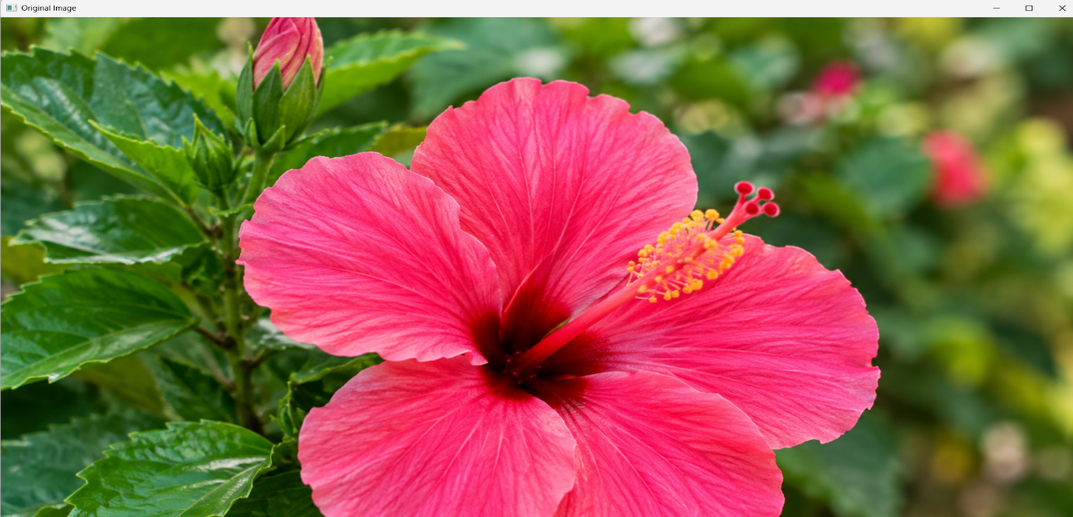
- Canny Edge Image
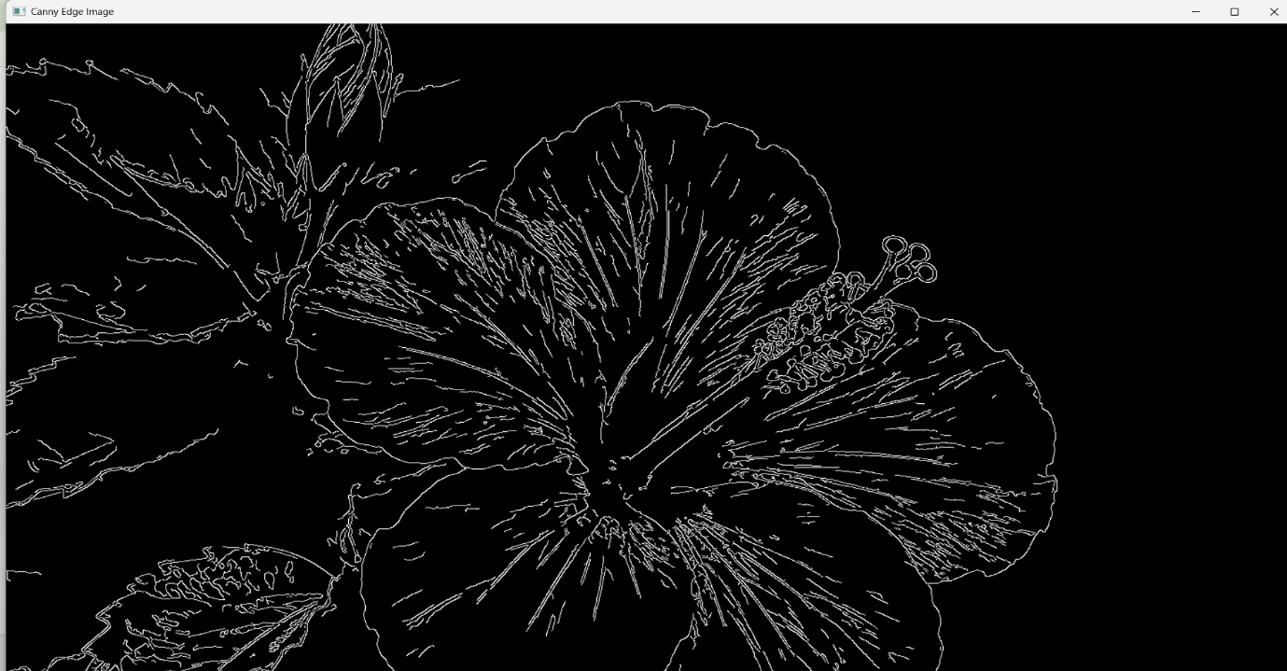
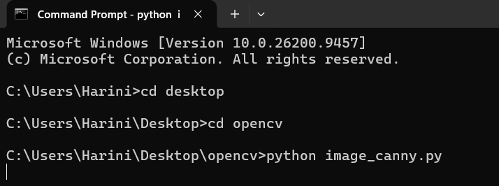
.RESULT
Thus, the given image was successfully read using Python and OpenCV, and the Canny function was successfully used to detect and display the outlines of the image.

